CMP 4271

# Task: Strategic and Twitch Skill.

## 4.1 Game Premise

The task was to create a game where the players work together to defuse a bomb. This game requires the strategic skills of the players. The game made by the team was: the players have to work together to answer riddles, each riddle represents a “wire” that the players are supposed to cut. If the players get all riddles right, then they win the game and the bomb does not go off.

## Materials

The materials needed are:

* The game timer.
* The bomb timer.

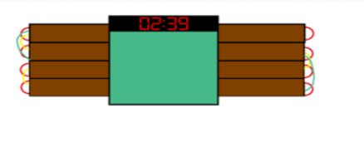

Figure 4.1. A bomb with a timer. The figure shows a bomb with a timer that was used during the game.

* A random riddle generator.

## Rules

The rules of the game are:

* Players are not allowed to look up the riddles or puzzles during the game.
* Players have 60 seconds to solve each puzzle or riddle.
* Players must work together to figure out the answers.
* Each player has only one re-spin, if they fail or skip a riddle.
* Players can answer the riddle at the end of 60 seconds.

## How to play

* Any player can spin the wheel at the start of the game.
* When a riddle or puzzle is generated, players have only 60 seconds to talk among themselves and answer.
* If the players fail a riddle or puzzle, they are allowed one free re-spin per riddle.
* When the players get all the puzzles right, the bomb is defused.
* If the players fail to get all the puzzles right, the bomb will go off.
* Players must answer all riddles in 4 minutes.

## Play Testing

The team conducted external play testing and it was noted by the play tester, Hou Yap, that the game would end too quickly if the players have 60 seconds to answer the riddle. The team thought about it and decided that the solution was to have the players answer the riddles at the end of 60 seconds. That would allow the game to continue for the allocated 4 minutes of play time and if the players fail to answer and choose to re-spin for another chance, it would add another 60 seconds to the game, making it longer.

During the internal play testing the team decided to make the game harder by using more difficult, lesser known riddle. Using more difficult riddles would force the team to work together and talk among themselves to generate answers. The change would also increase the players’ sense of urgency because the timer continues to move as they think frantically about the answer to the riddle. An example of a difficult and lesser known riddle would be “What word becomes shorter when more letters are added to it?”

## Experience

The members of the team were very ready and willing to work, they had good ideas and managed to find an already existing game that the members of the team could use as inspiration. The game was called Keep Talking and Nobody Explodes. The members of the team displayed their artistic skills by designing the bomb timer as well as the game layout.

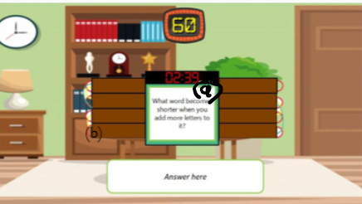

Figure 4.2. The Game Layout. This figure shows the general layout of the game along with the bomb which has a timer attached to it (b). In the centre of the bomb (a), the riddle is displayed.

The development jobs as well as presentation parts, were easily delegated to the members of the team.

## Members of the Team

The members of the development team were: Samiul Bari, Ngozi Egonu and Callum Weaver.